SCR results for year-end 2024
1. Introduction
1.1 Overview
This report summarises the Solvency Position of Smart Insurance Ltd (the Company) for year-end 2024 with comparison to the previous year-end.
The Solvency Ratio decreased by 2.0% from 150.8% to 148.8% since the previous year. Analysis of the drivers of the results is provided in Section 2.
1.2 Background
The capital regime for an insurance undertaking in the EU is governed by the Solvency II Directive. This directive requires insurance undertakings to report their solvency to the supervisory authorities on a regular basis, typically quarterly or annually.
1.3 Scope
The scope of this report covers the annual results of Smart Insurance Ltd in terms of:
- Solvency Capital Requirement (SCR)
- Own Funds
- Solvency Ratio
2. Results
Table 1 below summarises the solvency position of the entity for year-end 2024.
Table 1 – Summary of Solvency Position 2024 vs 2023
€m | 2024 | 2023 | Movement | Movement %
Market Risk | 105.0 | 111.1 | -6.1 | -5.5%
Counterparty Default Risk | 50.5 | 48.4 | 2.1 | 4.3%
Life Risk | 80.3 | 69.9 | 10.4 | 14.9%
Health Risk | 55.3 | 20.1 | 35.2 | 175.1%
Diversification Benefit | -78.0 | -62.4 | -15.6 | 25.0%
Basic SCR | 213.1 | 187.1 | 26.0 | 13.9%
Operational Risk | 19.9 | 17.8 | 2.1 | 11.8%
Deferred Tax Adjustment | -31.1 | -25.6 | -5.5 | 21.5%
Total SCR | 201.9 | 179.3 | 22.6 | 12.6%
Own Funds | 300.5 | 270.4 | 30.1 | 11.1%
Solvency Ratio | 148.8% | 150.8% | -2.0% | -1.3%
The table shows that:
- The Total SCR increased by 12.6% from €179.3m to €201.9m since the previous year.The largest contributor to the increase in the Total SCR by €22.6m is the increase in €35.2m by Health Risk risk.
- The Own Funds increased by 11.1% from €270.4m to €300.5m since the previous year.
- The Solvency Ratio decreased by 2.0% from 150.8% to 148.8% since the previous year.
- The Counterparty Default Risk, Life Risk, Health Risk BSCR increased over the year but Market Risk BSCR decreased.
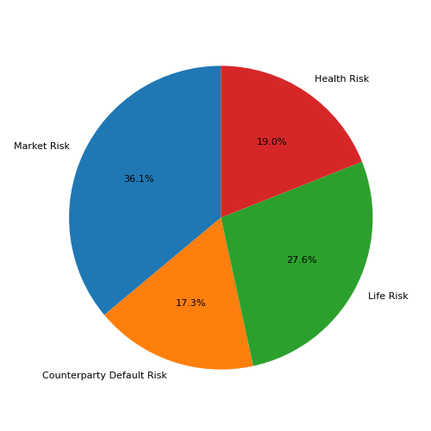
Figure 1: Composition of the Basic SCR - 2024
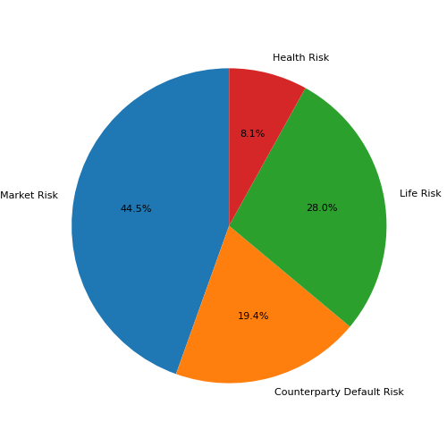
Figure 2: Composition of the Basic SCR - 2023
The proportion of Health Risk BSCR increased over the year but proportion of Market Risk, Counterparty Default Risk, Life Risk BSCR decreased. The increase in Life and Health risks is due to growth in business volume. Most of the growth came from Health Risks due to the introduction of a new product called ProtectMe.
3. Conclusion
The Company's solvency ratio of 148.8% is above its target of 125.0%.

